Does someone can explain how to edit the world_map.fc to show the ship transitions? @Kreitani you did it for Kingsgrove I think?

Hier0nimus (Jeroen) — heute um 17:39 Uhr

the beziers you mean?

Kreitani — heute um 17:39 Uhr

i used a blend that @Taubenangriff made

them exported it as an obj, and took the curve positions from that.

it's been a while tho

Taubenangriff — heute um 17:46 Uhr

any dummy on the world map could specify it's own position and the waypoints from self to other sessions

then each of the files gets an asset that links to the file

the world map then has a list of all files that should be displayed on the world map

that would be a dream

right now we have an .fc which is not patchable through modloader (fuck the cdata sections honestly ^^)

and it's a giant monolith file that contains all dummies and path information

so, it's not extensible at all

okay, so I think I made some progress. Drawing the curve in the blen file and export as obj. open in vscode to get the coordinates, bring them to the fc file. Let's get going 😂

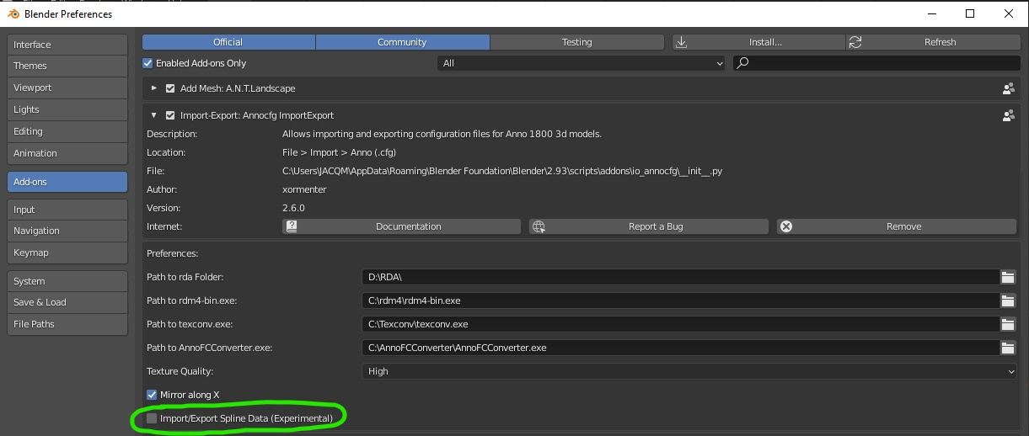

When you import the world map into blender with that option it will import all the curves from the fc file.

I start by deleting all the curves except one, delete all the point from that curve except the starting point.

Duplicate that point to draw your curves.

Export the file, copy the coordinate and past it yourself into the clean fc file.

VALiiiUM — heute um 19:06 Uhr

I honestly don't know, what I did with the exported coordinates is to use every x coordinate (depend on the complexity of the curve, maybe every 5 or 10) as a controlPoints

It work very well that way so I didn't try experimenting with that

Taludas — heute um 19:08 Uhr

Okay, so first, getting the fine curve in blender and after copying select some of the points as control points?

Taubenangriff — heute um 19:10 Uhr

It's based on indexing

VALiiiUM — heute um 19:11 Uhr

To get the order of the coordinate in the right order you should use the starting point of a curve (the departing point from the kontor) then duplicate that point as much as you need to draw your new curve

Taubenangriff — heute um 19:11 Uhr

Approximation mapping defines which approx points go where on the curve

The index of a number is the index in the curve vector

The number is the index of the final approx point

Taludas — heute um 19:15 Uhr

Okay, I didn't understand that part 😵‍💫 but it's okay 😂 as I don't really know how the whole curve thing works in general, I guess getting it to work is the only part that matters 😆